**Project Report**

**Title:- Manufacturing of sheet metal rolling machine**

**Submitted in partial fulfillment of the requirement for the award of**

**Diploma Mechanical Engineering**

**Submitted By: PRATHAM ASHOK ASRANI**

**Enrollment No. :- 1822004**



**Under the Guidance of : Prof. N. E. Pise**

**DEPARTMENT OF MECHANICAL ENGINEERING**

**GOVERNMENT PLOYTECHNIC, NAGPUR**

**(An Autonomous Institute of Government of Maharashtra)**

**SESSION: 2020-21**

**Page no. 01**

**CERTIFICATE**

**GOVERNMENT PLOYTECHNIC, NAGPUR**

**(An Autonomous Institute of Government of Maharashtra)**



**This is to certify to –**

|  |  |
| --- | --- |
| **NAME** | **EN.NO.** |
| **Pratham Ashok Asrani(Leader)** | **1822004** |
| **Mohit Anil Sonkusare** | **1822049** |
| **Bhavika Ajay Bhotmange** | **1822010** |
| **Pratham Bapunya Jengathe** | **1822032** |
| **Sahil Sunil Bharne** | **1722004** |
| **Abhijeet Vaidye** | **1722053** |

Of final year Mechanical Engineering students have submitted their **project report on Manufacturing of sheet metal rolling machine during academic session 2020-21** as a part of project work prescribed by Government Polytechnic, Nagpur for partial fulfillment for the diploma in Mechanical Engineering in sixth semester.

**Signature of Guide HOD Mech. Engg**

**SEAL**

**Page no. 02**

**ACKNOWLEDGEMENT**

We would like to place on record my deep sense of gratitude to our guide, **Prof. N.E.Pise sir** , department of Mechanical Engineering for his/her generous guidance, help and useful suggestions.

I express my sincere gratitude to **Dr. Rajesh G. Choudhary** Head of department of Mechanical Engineering for his stimulating guidance, continuous encouragement and supervision throughout the course of present work.

We are extremely thankful to **Dr. M. B. Daigavane**, principal for providing us infrastructural facilities to work in, without which thus work would not have been possible.

**Page no. 03**

**Abstract**

This project work titled ***“SHEET ROLLING MACHINE”*** has been conceived having studied the difficulties in making bending in sheet metal. This project facilitates in making bending accurate in sheet metal with easy. The project employee by using the roller for bending purpose by manual.

This machine can be used in various fields. Our project the sheet metal rolling is very simple in operation by using roller which is coupled with handle.

In Sheet Metal working industry, a wide range of power and hand operated machines are used. This machine is simple in construction and working.

Sheet metal rolling machine is used to do a process of turning the flat sheet metal of appropriate length into a desired curvature as the manufacturer wants or into a complete hollow cylinder. This metal rolling machine is used largely in industry of pharmaceutical machine manufacturing company. Rolling machine has an application in manufacturing of heat exchanger, pressure vessel, octagonal blender etc. The metal sheet is feed continuously between upper lower and two lower rollers. Freely in the circular hole at the both support end. The upper roller is an adjustable roller which slide upward and downward direction normal to the roller. In this project, the objective is to analyses the contact stress analysis on the end support of the rolling machine and the lifting force on handle of the rolling machine which result in slip due to the crushing stress.

**Page no. 04**

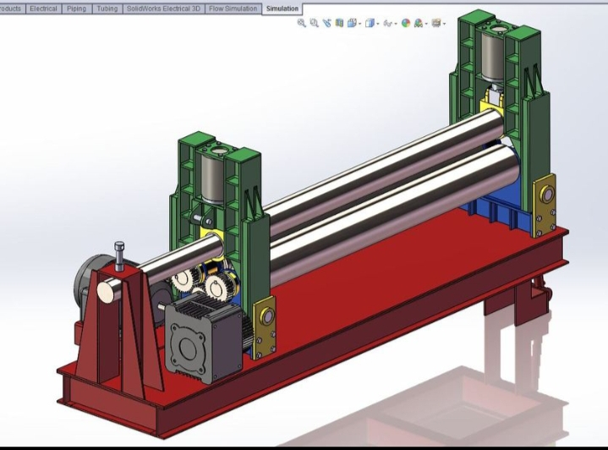

In **rolling**, the metal is plastically deformed by passing it between rollers rotating in opposite direction. The main objective of **rolling** is to decrease the thickness of the metal. Ordinarily, there is negligible increase in width, so that the decrease in thickness results in an increase in length.

**Page no. 05**

**GOVERNMENT POLYTECHNIC, NAGPUR**

**An Autonomous Institute of Government of Maharashtra**

**DEPARTMENT OF MECHANICAL ENGINEERING**

**CONTENT**

|  |  |  |
| --- | --- | --- |
| **SR. NO.** | **TOPIC** | **PAGE NO.** |
| **01** | **INTRODUCTION** | **09** |
| **02** | **MATERIAL AND DESIGN** | **14** |
| **03** | **TYPES** | **17** |
| **04** | **DETAILS OF TYPES** | **17** |
| **05** | **CONSTRUCTION** | **19** |
| **06** | **WORKING PRINCIPLE** | **24** |
| **07** | **WORKING** | **24** |
| **08** | **ADVANTAGES & DISADVANTAGES** | **32** |
| **09** | **APLLICATIONS** | **34** |
| **10** | **DESIGN PICTURES** | **36** |

**Page no. 06**

**LIST OF FIGURES**

|  |  |  |
| --- | --- | --- |
| **SR NO** | **TOPIC** | **PG NO** |
| **01** | **CNC PLATE ROLL MACHINE** | **09** |
| **02** | **CNC PLATE BENDING ROLL MACHINE BY HACO** | **10** |
| **03** | **CONCEPTUAL DIAGRAM** | **12** |
| **04** | **M/C HAS 4 FOLLER** | **15** |
| **05** | **M/C HAS 3 ROLLER** | **16** |
| **06** | **BEARING BLOCK ASSEMBLY** | **18** |
| **07** | **CONCEPTUAL WORKING DIAGRAM** | **21** |
| **08** | **PICTURES OF SPECIFIC APPLICATIONS** | **33** |

**Page no. 07**

**LIST OF TABLES AND VIDEOS**

|  |  |  |
| --- | --- | --- |
| **SR NO** | **TOPIC** | **PG NO** |
| **01** | **WORKING VIDEO** | **26** |
| **02** | **PICTURES OF SPECIFIC APPLICATIONS** | **33** |
|  |  |  |

**Page no. 08**

**CHAPTER NO. 01 – INTRODUCTION**

**SHEET METAL ROLLING MACHINE**

A **plate rolling machine** is a machine that will roll different kinds of metal sheet into a round or conical shape. It can be also called a “roll bending machine”, “[plate bending machine](https://en.wikipedia.org/wiki/Plate_bending_machine)” or “rolling machine”.

There are different kinds of technology to roll the metal plate:

* Four-roller machines have a top roll, the pinching roll, and two side rolls.

The flat metal plate is placed in the machine on either side and "pre-bent" on the same side. The side rolls do the work of bending. The pinching roll holds the plate.

* Three-roller machines (variable pitch aka variable geometry) have one pressing top roll and two pressing side rolls.

The three-roll variable pitch works by having all three rolls able to move and tilt. The top roll moves in the vertical plane and the side rolls move on the horizontal plane. When rolling, the top roll presses the metal plate between the two side rolls. The advantage of having the variable three roll is the ability to roll many thicknesses and diameters of cylinders.

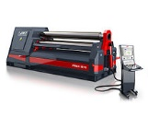

**FIG 1 CNC PLATE ROLL MACHINE** **Page no. 09**

For example; The side-rolls are what produce the mechanical advantage. With the side rolls all the way open, one has the maximum mechanical advantage. With the side rolls all the way in, you have the least mechanical advantage. So, a machine has the capability of rolling 2-inch-thick material with the maximum mechanical advantage, but a job is only 1/2 inch thick. Reduce the mechanical advantage and one has a machine that can roll from 1/2 to 2 inches thick.

Plate rollers can be powered and controlled in multiple ways. Older plate mills are driven by electric motors and newer ones are directed by programs that are loaded into the CNC controller. When thinking about plate roll acquisition, industrial machinery companies like [Provetco Technology](https://provetco.com/collections/plate-roll-machines) will ask about the working length of the roller, the maximum thickness of the material, top roll diameter size as well as the minimum thickness of the material. Furthermore, the material yield is another critical component to disclose to machinery companies when looking for a plate roller.

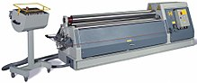

**FIG 2 CNC PLATE BENDING ROLL MACHINE BY HACO**

**Page no. 10**

Sheet Metal industry is a large and growing industry. There are many special purposes machine used in this industry today. The proper selection of the machines depends upon the type of the work under taken by the particular industry. There are many examples of Sheet Metal work, which can be seen in our everyday life. The metals generally used for Sheet Metal work include black iron sheet, copper sheet, tin plate, aluminum plate, stainless steel and brass sheet.

Our project the **“SHEET METAL ROLLING MACHINE”** finds huge application in Sheet Metal industry. Rolling is the process of bending sheets to a curved form. The article in the shape of cylinders is made by rolling roller.

Rolling operation can be done on hand or power operated rolling machines. In forming cylindrical shapes, a gradual curve is to be put in the metal rather than sharp bends. The gap between the rollers can be regulated by hand operated screws.

Sheet metal is available in flat pieces or as a coiled strip. Various forming process in sheet metal include:

**Page no. 11**

* **Punching**
* **Roll forming**
* **Rolling**
* **Spinning**
* **Stamping**
* **Stamping**
* **Bending**
* **Deep drawing**
* **Expanding**
* **Curling**
* **Press brake forming**
* **DE cambering**
* **Ironing**

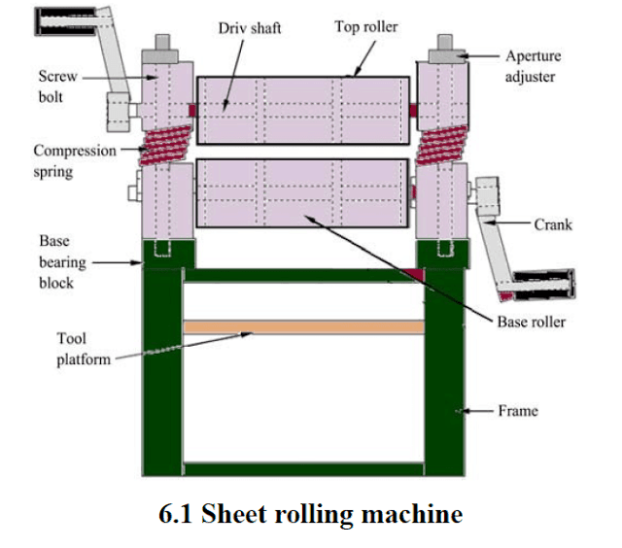

**FIG 03 :- CONCEPTUAL DIAGRAM**

**Page no. 12**

The plate rolling processing is carried out by means of machines called plate rollers, which are substantially composed of three parallel rollers, arranged according to the vertices of an isosceles triangle. The sheet metal, passing between the lower and upper rollers, undergoes a curvature, the so-called radius, the radius of curvature depends on the mutual position of the three rollers: in order to have wide radius the rollers must be moved away while, on the contrary, they must be approached to result in bends with small radius.

The dragging of the sheet is caused by the rotation of the motorised upper roller, the two lower rollers instead rotate freely and have only the task of supporting the sheet.

A normal plate rolling process requires different passages in which the motion of translation and the approach and removal of the rollers are duly regulated.

Today also the world of plate rolling machines has undergone a huge evolution from the technological point of view. More and more often these machines are conveniently equipped with a computer board for the complete automation of processing, as well as the traditional [three-rolls plate rolling machine](https://makinate.com/sheet-metal-machines/plate-bending-rolling-machines-3-rolls/) has an upgraded version even more versatile equipped with [4-rolls plate vending rolling machines](https://makinate.com/sheet-metal-machines/plate-bending-rolling-machines-4-rolls/).

**Page no. 13**

**CHAPTER NO 2 :- MATERIAL USED IN MANUFACTURING**

Ferrous metals can include steel, stainless steel, and galvanized. Various steel **roll manufacturers** in India utilize these to create steel rolls. Steel comprises of iron and is malleable below its melting point by one temperature range without any heat treatment.

Basically – **STEEL** (**Fe 500)**

**permissible** tensile **stress**  = 275 N/mm2

**permissible** shear **stress**   = 137.5 N/mm2

**permissible** compressive **stress**  = 275 N/mm2

**PROPERTIES :-**

* Weldability. Weldability is a **property of steel** that greatly affects how easily it can be used in construction and fabrication.
* Hardenability.
* Machinability.
* Workability (Bending / Forming)
* Wear Resistance.
* Corrosion Resistance.
* Yield Strength (Yield Stress or Point)
* Tensile Strength (Ultimate Stress)

**BENDING CAPACITY :- 3mm of sheet**

**Page no. 14**

**DESIGN OF LEVER**

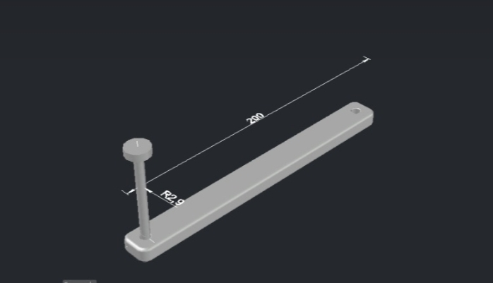FIG :- LEVER

Thickness of lever – 12mm.

Length of lever – 400mm.

Material used :- fe500 (steel)

1) Permissible stress-

• Tensile - 275 N/mm²

• Shear - 137.5 N/mm²

• Compressive - 275 N/mm²

F.O.S = 3

Updated value – **Page no 15**

• Tensile - 275 x 3 = 825 N/mm²

• Shear - 137.5 x 3 = 412.5 N/mm²

• Compressive - 275 x 3 = 825N/mm²

2) Calculations

Basically bending and shear stress occurs.

a) Bending stress calculation

Load applied by human (f) = 400N

M =P x L =200 x 400 = 80000 N.mm.

M= P *L = 200 * 400 = 8,00, 00N.mm

Σb=M/Z. Z = 1/6 * t * b. Where b = 1.6 t

Σb=(80000*6)/(12*1.6*12) …….t = t.6B

Σb=347.22

Shear Stress-

Occurs at handle corner

Τsmax = ½ √(σb²+4τ3)2

Τs =f/A=400/πr² = 400/(π*3²)

Τs=14.15 N/mm2

Τmax =√(σb2+τ3 sq*1/2)

=1/2 * √((347.22)² x (14.15)²)

Τmax =347.508N/mm²

Σmax=348 < σbper =825 N/mm²

Τsmax=348 < τsper =412.5 N/mm²

Hence, design is safe.

**Page no 16**

**CHAPTER NO 3 & 4 :- TYPES OF ROLLING MACHINE AND THERE DETAILS**

There are different kinds of technology to roll the metal plate:

**1) Four roller machine:** Four-roller machines have a top roll, the pinching roll, and two side rolls. The flat metal plate is placed in the machine on either side and "pre-bent" on the same side. The side rolls do the work of bending. The pinching roll holds the plate.

**FIG 3 :- CONCEPTUAL FIG**

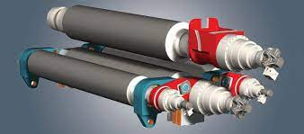

**FIG 4 :- M/C HAS 4 FOLLER**

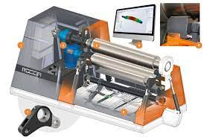

**Page no. 17**

**2) Three-roller machines:** three-roller machines (variable pitch aka variable geometry) have one pressing top roll and two pressing side rolls. The three-roll variable pitch works by having all three rolls able to move and tilt. The top roll moves in the vertical plane and the side rolls move on the horizontal plane. When rolling, the top roll presses the metal plate between the two side rolls. The advantage of having the variable three roll is the ability to roll many thicknesses and diameters of cylinders.

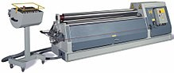

**FIG 05 :- M/C HAS 3 ROLLER**

**Page no. 18**

**CHAPTER NO. 5 :- CONSTRUCTION OF ROLLING M/C**

**1 THREE ROLLER M/C :-**

The major design components consisted of three rollers supported on spring loaded bearing blocks mounted on a frame.

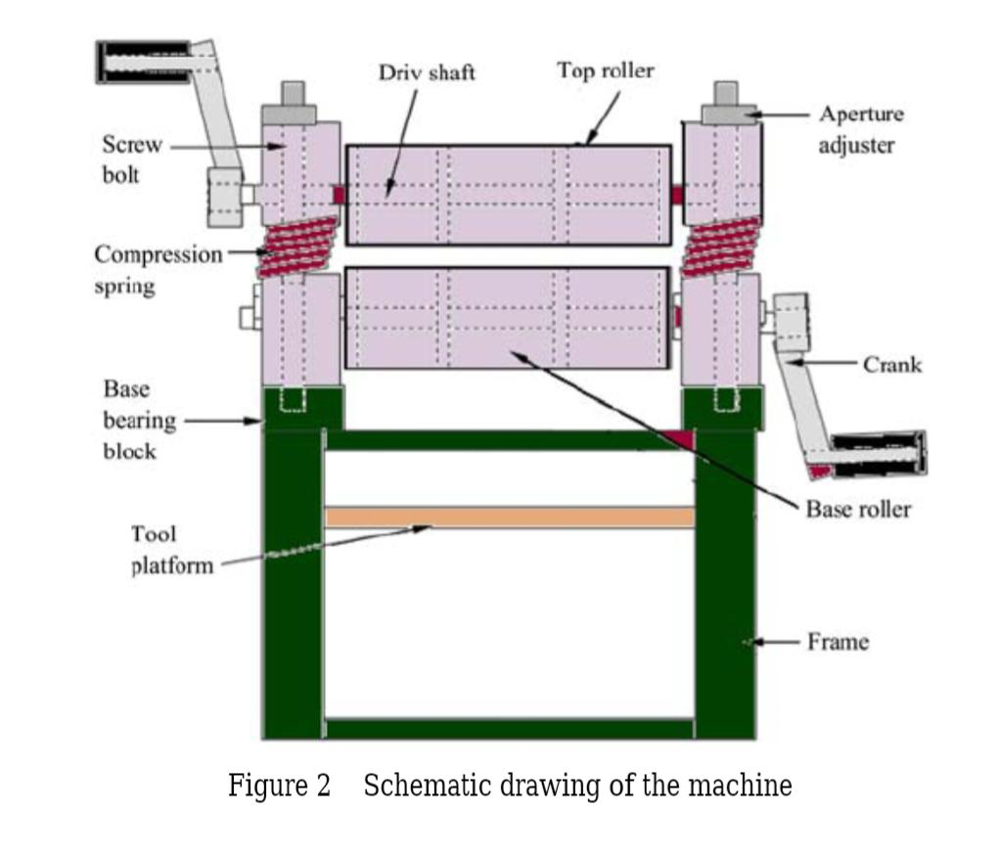

The rollers were arranged in triangular form; two sets of rollers below and one above. The upper roller provide the bending force while the back base roller provides the required driving force and the front end roller bends the metal according to set radius of bend. Two base bearing blocks (made of hard wood) mounted on the frame provided supports for the base rollers while the press roller is supported by two wooden bearings blocks, and mounted on a U-shaped metal bracket.

**Page no. 19**

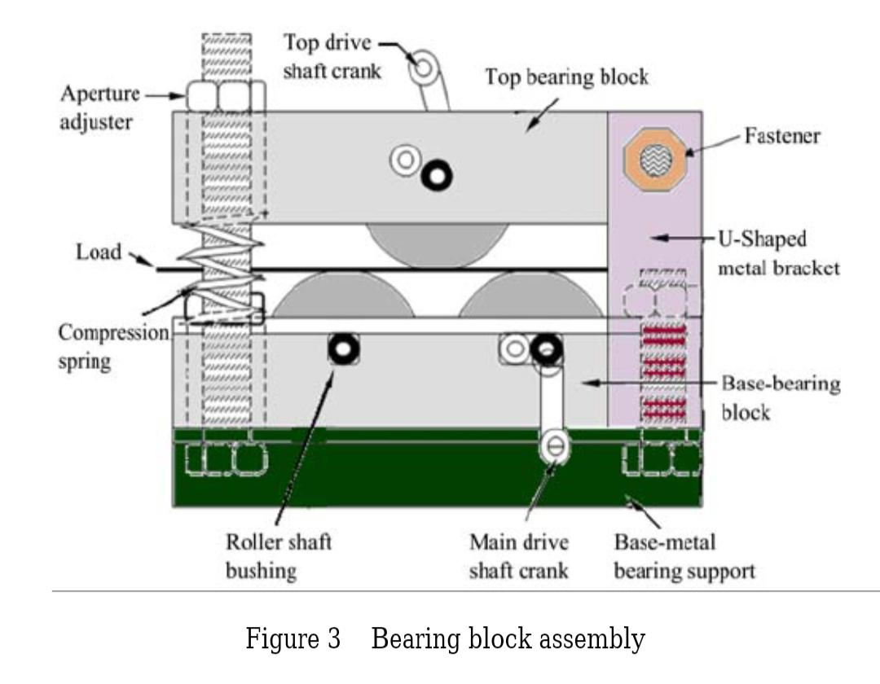

The clamping beam is spring loaded (using old car valve-springs) to simplify positioning and radius adjustment on the sheet. The clamping beam is also fully adjustable fore and aft by means of two threaded knobs, which results in very accurate bends. The shaping beam is simply supported and has a well-positioned stout drive handle.

Aperture adjuster on each block assembly ensures easy loading of work piece and adjustment to required radius of bent. The free end of the top bearing block is spring loaded to increase or to reduce top-base roller clearance. Two other bores on each bearing blocks provide an adjustment for the roller gap variability thereby making it possible to roll sheet metal to different sizes. **Page no. 20**

The top roller provides the bearing load (bending force) and also compliments the driving roller when working on thick materials. The lower back roller provides the necessary driving forces while the idler roller does the bending and material delivery. There are two crank levers, one on the top roller and another on the front-end roller. The lever (handle) coupling head has a square configuration which fits into the square end of the roller shaft.

The frame structure is made of (50×50×5) mm angle iron for the purposes of strength. The height of the entire machine when mounted on the frame is 800 mm. This height is convenient for operators of an average height of 1,680 mm.

A tool table is provided below the rollers for safe keeping of tools and cranks. The roller head assembly is detachable from the frame and can be mounted on a table to be used as a table top machine for tinkering work.

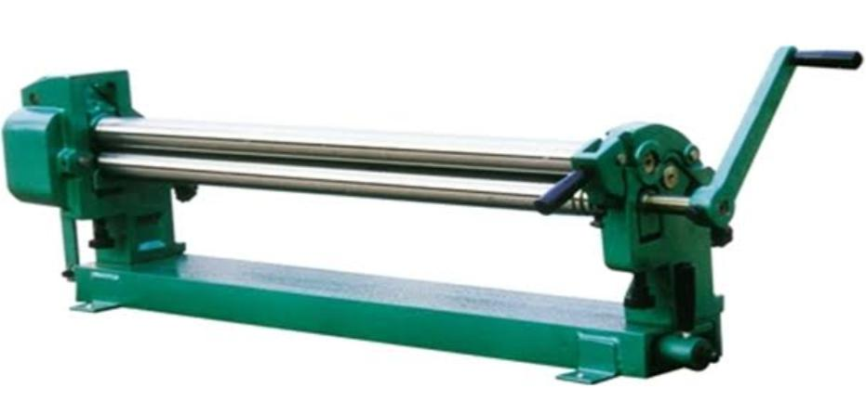

**Page no. 21**

**2 FOUR ROLLER MACHINE**

Plate rolling machine is a kind of public forging machine equipment that can bend non-metallic plates into cones, spheres, cylinders or other shapes. This performance is used by large widths. Construction and machine building. The four-roller plate rolling machine is suitable for the bending and forming of sheet metal. It can roll round, arc, and conical workpieces within a certain range. The metal plate can be roughly leveled on this machine.

The four-roller rolling machine and the three-roller rolling machine have different roller movements, but they work on the same principle and also use the principle of three-point fixed circle for rolling with different radius. The position of the upper roller is fixed, and the lower roller linearly moves upward to clamp the steel plate. The rollers on both sides move in a straight or curved line to adjust the curvature radius of the roll. **PAGE NO. 22**

Any machine should be operated correctly according to the process requirements. Let’s talk about the main points of the correct operation of the four-roller plate rolling machine.

1. The rolling machine must be managed by a special person.
2. The operator must be familiar with the structural performance and use method of the rolling machine, and the operation can only be performed with the consent of the responsible manager.
3. Before starting, carefully check whether the safety device is intact.
4. During operation, it is strictly forbidden to put hands and feet on rollers, transmission parts and workpieces.
5. After work is interrupted, the clutch should be set to neutral.
6. Coordinated operation by multiple persons must be directed by a special person.
7. Overload work is strictly prohibited.
8. The tilting reset of the upper roller’s lifting and reversing bearings and the balance of the upper roller must be performed after the main drive is stopped.
9. It is forbidden to pile up workpieces and sundries at the work site, and keep the machine tool and the site clean at all times.
10. The operation is completed, the power shall be cut off and the power box shall be locked.

Four-roller rolling machine is an important equipment in the production of the enterprise. It must be operated in the correct way during use. Nantong Tel specializes in the production of three-roller rolling machine, four-roller rolling machine and other equipment. Our products are tested strictly in accordance with the process standards and leave the factory. Products serve our customers.

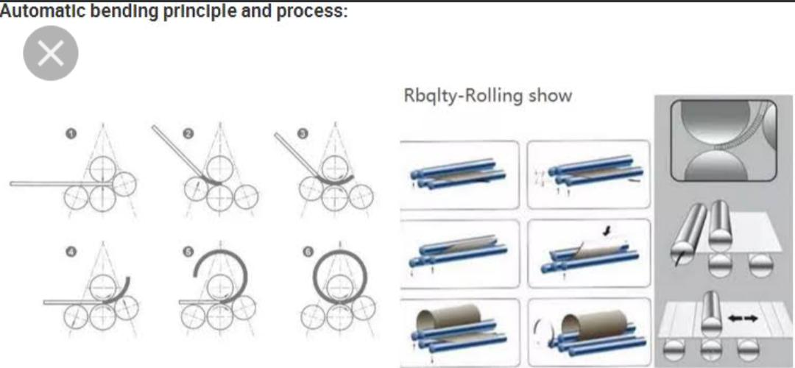

**FIG 07 :- CONCEPTUAL WORKING DIAGRAM**

**PAGE NO. 23**

**CHAPTER NO. 06 & 07 :- WORKING PRINCIPLE AND WORKING**

Roll bending machine has also been called rounder and roller machine, which is universal farming equipment for rolling metal plate into the cylinder, cone, covered and other shapes .

According to the principal of the three point for men’s haircut the relative position change and rational motion of the working role make the metal sheet produced continuous plastic deformation to obtain the determined shape of the workpiece. **PAGE NO. 24**

It is widely used in boiler shipbuilding, petroleum, chemical, metal structure and machinery manufacturing industries.

roll bending machine usually take to lower as active roll, can realize positive and reverse rotation. One upper roller is follower roll can move vertically up and down.

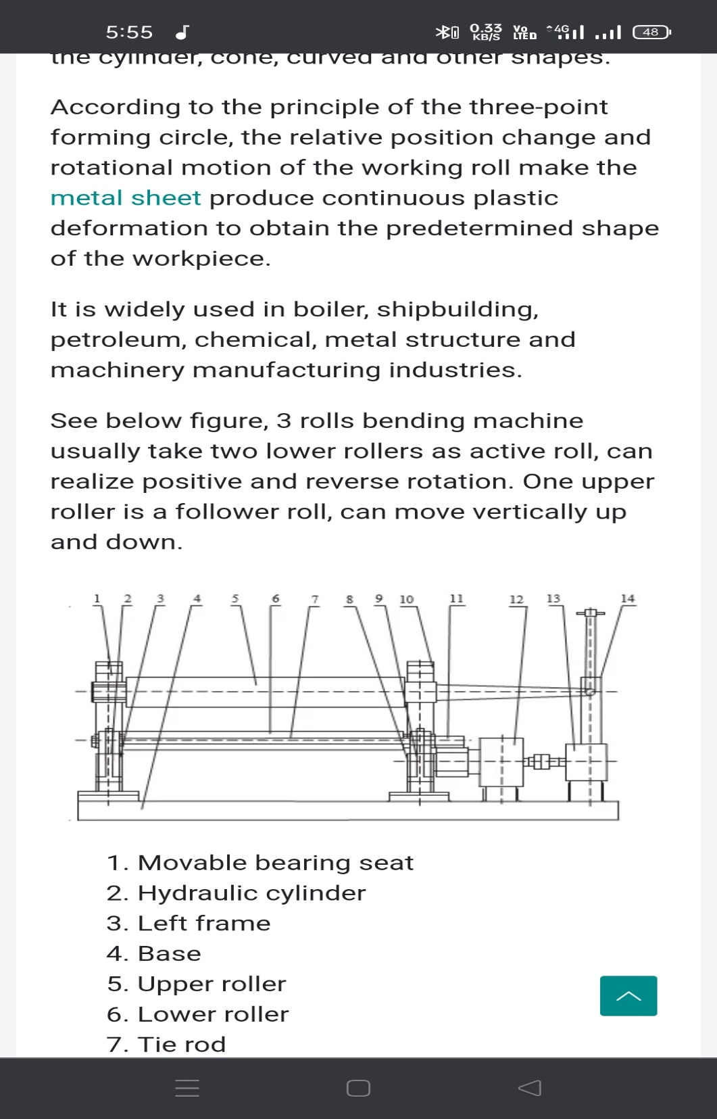

* Movable Bearing Seat
* Hydraulic Cylinder
* Left frame
* Base
* Upper Roller
* Lower Roller
* Tie road
* Right frame
* Hydraulic Cylinder
* Fixed Pairing Seat
* Roller Gear
* Reducer
* Motor
* Unloading Device

When rolling steel plate, the plate is placed between the upper and lower roller and the three cutting point that are exposed to the metal sheet by three rules can make the blade bent into a covered or closed circle.

Therefore, the forming process of sheet metal can be regraded as the three roll bending machine to make a continuous three point bending process. **PAGE NO. 25**

During one end of the metal plate is fit into three roller plate between the upper and lower and then top roller bring downward displacement on the metal plate which make the plate under it generates a certain plastic bending the formation due to compression.

When the roller is rotating there is a friction between the plate and the role so when the roll is rotated the plate also move along its longitudinal direction .lower roller under positive and negative rotation alternative and rolled plate move back and forth to lower rotation and the friction try plate and roller move.

Meanwhile, the upper roller continue to add downward pressure on the roller, the upper roller move back and forth on the plate.

When the plate pass the bottom of upper roller (the roller definition zone) in turn, and stress exceeds the yield limit ,it will produce plastic deformation, the plate obtained the plastic bending the formation along the full length, and processed into the required shape.

Adjust the relative position between the upper and lower rolle properly, and the plate can be bent to a radius not less than the radius of the upper roller .

The following is the working principle drawing of symmetrical three roll bending machine.

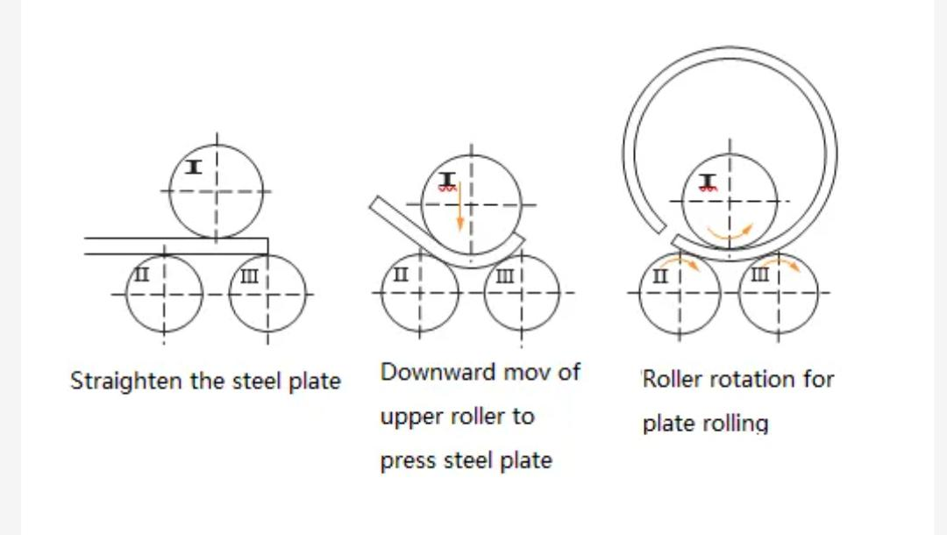

Driven roller 2,3 is driven by motor and reducer which rotate in the same direction at the same speed (or in opposite direction).

Because of the friction between the roller and the plate ,the plate is driven forward and the roller is rotated.

Adjust the position of the roller properly and the role of different curvature of the plate can be made.

If the workpiece cannot meet the desired curvature after a rolling process the upper roller can be reduced properly , and then make the reverse rolling again and again until it is rolled into the desired shape.

**PAGE NO. 26**

As can be seen from the about figure the three roll of the symmetric three roller bending machine arranged in a isosceles triangle, so in the rolling process , the two end of the workpiece are bound to leave a straight line.

The length of the straight line segment is about half the distance of the centre of the two lower roller. The part of the straight line is the place where the roller cannot roll, which is the biggest disadvantage of the symmetrical three Axis roller.

Despite the disadvantage of the symmetrical 3 roller plate bending machine, it has been widely used because of the simple structure, convenient operation and low cost.

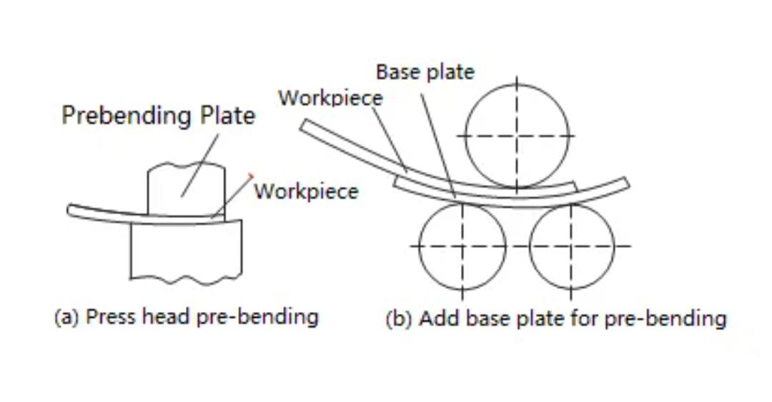

For another asymmetric three roller bending machine the arrangement of the shaft roller is designed to eliminate the straight line segment on the rolling workpiece. **PAGE NO. 27**

The characteristics of such rolling machine are two lower roller can we adjusted vertically.

Any lower shaft roller can be adjusted to the centre distance of the upper roller, and the other roller is raised to the appropriate position. The starting end of the steel plate can be bent and rolled.

After half roll ,change the alignment of the two rollers , continue rolling, and eliminate the straight line segment at the end of the workpiece.

The workpiece can also be turned around, the back and become front end for rolling, which can also eliminate the line segment.



**VIDEO 1 :- WORKING VIDEO**

**PAGE NO. 28**

**WORKING OF FOUR ROLLER MACHINE**

According to the three-point forming principle, the plate bending machine continuously elastically and plastically bends the plate by utilizing the relative position change and the rotary motion of the work roll, thereby obtaining a workpiece having a predetermined shape and accuracy.

The structure of the four-roll plate bending roll is shown. It is mainly composed of low frame, rollover device, upper roll, lower roll, double roll, lifting frame, base, balance device, transmission device, electrical system, hydraulic system and so on.

Structure of four-roll plate rolling machine

Structure of four-roll plate bending machine

The work roll of the four-roll plate bending roll consists of four rolls: upper roll, lower roll and double roll.

The upper roller is the main drive roller and is embedded in the upper and lower frames through the bearing body. Its position is fixed and can only be rotated. **PAGE NO. 29**

The lower roller is fixed on the bearing seat. To compensate for the thickness of the bent plate, the bearing housing can move linearly within the sliding path of the frame.

The rollers on both sides are mounted on the bearing housing. In order to obtain a specific radius of curvature of the cylinder, the side roller bearing housing can be moved up and down at an angle relative to the vertical direction.

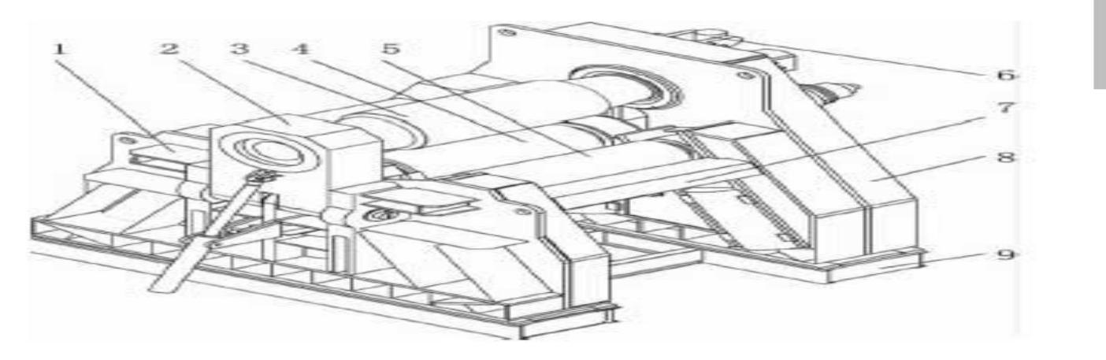

* Left frame
* Rotary device
* Roll up
* Scroll down
* Beside the drum
* Balance device
* Connecting beam
* The correct framework
* Base
* In general, rolling a metal plate into a cylindrical workpiece on a four roller plate bending machine consists of four processes, namely:Center-aligned, Pre-bending, scroll, Roundness correction
* During the operation of the calender, the front end of the pressure roller plate is first placed between the upper and lower rollers, and the center (on one side of the high pressure roller, the platen end is aligned with the side pressing roller) is aligned, and then the lower roller pressing plate is raised. Lift the other side of the pressure roller to apply a force to bend the end of the metal plate.
* When pre-bending the other end of the plate, the metal plate does not need to be removed from the mill. Move the circuit board to the other end of the machine and pre-bend in the same way.
* Then continue to scroll using one feed or multiple feeds until the desired cylindrical radius of curvature is reached
* Finally, roundness correction is performed to obtain the desired roundness and cylindricity.
* It can thus be seen that when using four rollers to bend the circuit board, the circuit board must be placed once in the rolling mill in order to realize all the bending rollers.

**PAGE NO. 30**

The working principle of 4 roll plate bending machine is similer to that of 3 roll plate bending machine but only the difference being it has one extra roll below the top roll which works as a clamping roll or more commonly known as pinchincing roll.

The main advantage is that the plate can be feed horizontally since the bottom and one pressure roll work as a support roll for plate ( in case of 3 roll machine plate is required to feed in a slant position)Also the pressure roller on opposite side works as a reference surface and plate can be fed at perfect right angle to pressure roll or machine.

After the plate is held firmly between top roll and pinching roll , the pressure roll advances to form desired radius on plate edge and adjacent area as shown The radius thus formed is checked with the template and same procedure is repeated till the templates matches with pre bent/pre pinched edge of plate.

After pre pinching the one edge of plate the same procedure is repeated on the another edge of plate to form pre pinching radius.

After forming desired radius on both the edges ,the rolling/bending is carried our by rotating all rolls in a reverse and forward direction till the complete circle is formed.

It is possible to form different shapes like square, rectangle, polycentric, elliptical,etc shapes more precisely ,but it is must that this are formed in a single pass and machine with PLC based controls is most suitable for this application.

Also this machine is most suitable for mass production type components which requires repeatedly same output results mass.

For engineering shop where same size of rolled products are required to be produced in small quantity and the sizes may change on day to day basis depending on job type ,the shell can be produced by rolling completed in multiple pass.

**PAGE NO. 31**

**CHAPTER NO. 8 :- ADVANTAGES OF SHEET METAL ROLLING MACHINE**

1. Do not need to bend the end, with fast processing speed
2. It is possible to do high precision shaping in one stroke
3. Even through pinching, cutting, rolling the metal plate will not produce crack and irregular wrapping
4. Do not create wrinkles, do not cause scratches on the surface of the parts
5. If increase the rolling reduction, even the two roller spacing changed, but the diameter of the parts don’t change, so the requirement for precision is not high, and the use of apparatus is simple
6. Easy to operate, no cumbersome steps are required
7. The possibility of error is small
8. It can bending medium thickness plate without slipping.
9. Machine cleaning is also very convenient
10. For the conditions and requirements of the roller, the manufacturer can also provide customers with solutions and methods in the first time.
11. In terms of materials, cleaning and maintenance are very easy
12. Low maintenance rate
13. Does not need to equip with expensive side push device
14. Able to rolling large angle conical workpiece
15. Almost has no pre-curving linear segment.

**PAGE NO. 32**

**DISADVANTAGES OF SHEET METAL ROLLING MACHINE**

* 1. Due to each change in the diameter of the making parts need to make guide roller wheel, it is not suitable for multi-variety and small-batch production.
  2. It cannot be processed with thick plate and the maximum thickness of the plate is 6 ~ 9mm.
  3. Skilled workers required for manual operating process.
  4. More time required.
  5. Applicable up to 8 mm thick sheets.
  6. Chances of accident due to improper concentration on work.
  7. As it is a prototype model, here bending is limited up to the thickness of 4 mm for higher thickness of specimen this machine size should be increased.
  8. High cost of equipment.
  9. Poor finish and poor dimensional accuracy.
  10. Suitable for large sections production.
  11. Deformation limited to small reductions.
  12. It is limited to only a few shapes and variations such like square, round, and flat.
  13. Rolling of 3 meter length and 2mm

Thick-ness is not possible in machine.

* 1. It was very difficult to maintain production schedule and cost.
  2. We were to dependent on out – sources.

**PAGE NO. 33**

**CHAPTER NO. 9 :- APPLICATION OF SHEET METAL ROLLING MACHINE**

1. It is used in various wind tower

towers, such as offshore wind towers and power station towers on mountain peaks

1. It is used to produce parts of aircraft and arospace components
2. Used in shipbuilding industry manufacture products of different shapes
3. In energy sector roller machine can roll heavy, extra thick sheets to build nuclear reactor vessels and turbine casings
4. In the decoration industry, it can complete the manufacture of stainless steel plates and doors, as well as the decoration of some special places
5. In the power industry, the bending machine can make plates into different sizes, such as computer cases, electrical cabinets, refrigerator air-conditioning shells, etc.
6. Various stainless steel kitchenware in the kitchen and catering industry
7. In the communications industry, street light poles, communications towers, traffic signal poles and monitoring poles are curved
8. It is used in the production of nearly all types of cylindrical product
9. It’s application extends to a vast array of items including pressure vessels (Heavily used in the Oil and Gas Industries)

**PAGE NO. 34**

**SPECIFIC APPLICATION OF SHEET METAL BENDING**

1. Outer cylindrical casing for motors employed in submersible pumps
2. Hydraulic and pneumatic cylinders
3. Bodies of shells and condensers
4. Dairy equipment
5. Compressors storage tanks

|  |  |
| --- | --- |
| **PICTURES OF SPECIFIC APPLICATIONS** | |
|  |  |

**PAGE NO. 35**

**CHAPTER NO. 10 :- DESIGN PICTURES**

|  |  |  |
| --- | --- | --- |
| **DESIGN PICTURE** |  | |
|  | |  | |
|  | |  | |
|  | |  | |
|  | |  | |

**Page no 36**